The best healthy-eating diet for diabetes

Social media examples

A diabetes-friendly diet:
✅Helps control blood sugar
✅Rich in nutrients; low in fat
✅Based on eating moderate amounts of food
✅Encourages eating at regular intervals during the day
Let’s explore this more: The best healthy-eating diet for diabetes
#LiveLifeWithVitality

Quick nutrition tips if you’re living with diabetes:
Make an appointment with a dietitian
Eat more vegetables
❌Limit alcohol
‍Cook more at home
Time your eating
Learn more: The best healthy-eating diet for diabetes
#LiveLifeWithVitality

The American Diabetes Association suggests a simple way of eating
called The Plate Method:
½ your plate with non-starch vegetables
¼ with lean protein
¼ with quality carbs
... and keep hydrated!
Learn more: The best healthy-eating diet for diabetes
#LiveLifeWithVitality

Article

SPOILER: a diet for someone living with diabetes is based on healthy eating principles which can apply to most people, so don’t be intimidated by the theme of this article. In fact, whether you’re living with diabetes, prediabetes or just wanting to eat more healthily to better manage your weight – read on.

Let’s start with the aim of this diet. This is a healthy-eating plan that helps you to control your blood sugar – and it should be rich in nutrients; low in fat. This type of eating plan is based on eating moderate amounts of food at regular intervals throughout the day. By doing this, you’re able to keep your energy levels steady and avoid any blood sugar level spikes. This is important because if you don’t control your blood sugar, it can lead to high blood sugar (known as hyperglycaemia) which can cause serious complications in the long-term, like heart and kidney damage.

To help avoid this, here are some recommendations from our Vitality dietitians:

- Book a dietitian consult

If you are already living with diabetes, or at risk of prediabetes, our first nutrition tip is to chat to a dietitian. They will sit with you and build an eating plan that is personalised to your lifestyle – taking into account your food preferences and daily schedule. A registered dietitian will also help you to set nutrition goals with easy-to-action suggestions to improve your eating habits. A key focus here is often portion size. How much you eat will depend on a range of factors including your current weight, goal weight, medication you’re on, your age and even how much exercise you do. They’ll then use this information to build the best eating plan for you, and importantly, one that you’re most likely to stick to.

- Up your veg

As part of this dietitian session, you’ll be advised to increase the amount of fibre, found in foods such as vegetables, fruits and legumes, in your diet. The American Diabetes Association offers a simple way of meal planning that focuses on eating more vegetables called The Plate Method. Here, you fill half of your plate with non-starch vegetables, such as carrots, tomatoes and leafy greens like spinach and kale. These types of vegetables are high in fibre and lower in digestible carbs (what your body absorbs) so they don’t affect your blood sugar levels as much. For the rest of your plate, opt for lean protein and quality carbohydrates – and make sure you keep hydrated, making water your drink of choice.
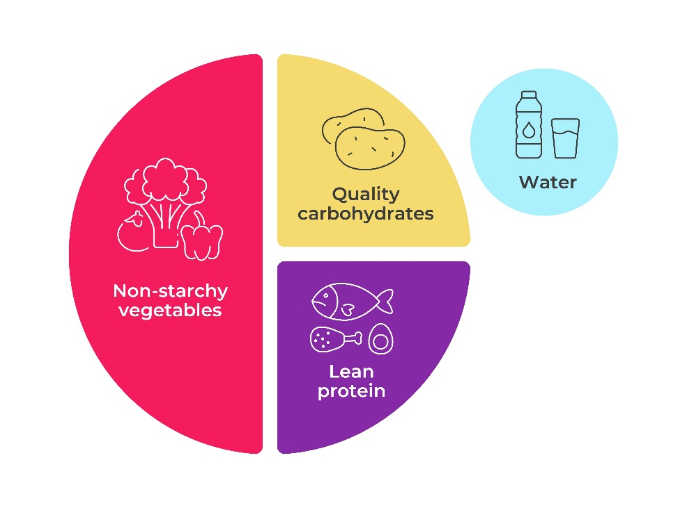

- Foods to limit

It’s also helpful to know what foods to reduce in your diet. Unfortunately for us all, a lot of the ‘convenience’ foods and drinks out there are high in sugar, salt and fats, such as biscuits, crisps, chocolates, cakes and sugary drinks. Refined carbs and added sugars are broken down quickly and can cause blood glucose to spike, while saturated fats and salt increase risk of hypertension and heart disease. Alcohol should be limited as this increases your risk of low blood sugar and is especially dangerous if you drink on an empty stomach.

- Cook more at home

To avoid the pitfalls of ultra-processed foods with hidden (bad!) ingredients, prepare your meals from scratch so that you control exactly what’s going into your food. This is also a great opportunity to involve your loved ones in the meal preparation process. Not only is this a fun family-time activity that builds connection and healthier habits, but it also helps your family to appreciate the changes you’re making in your life and to support you on your diabetes journey. When buying packaged foods, pay more attention to the food labels on the packaging so that you can choose options that are lower in sodium or saturated fat.

- Plan to eat at regular times

For people living with diabetes, it’s not just about what you eat, it’s when you eat. A healthy eating plan is based on eating at regular times which helps your body to better use insulin that it makes (or that you get through medication). Speak to your doctor and dietitian about the right meal pattern for you.

Need some meal-spiration?
Here’s a sample menu adapted from the American Diabetes Association that you can try out. This shows that following a diabetes-friendly eating plan can be quick and easy.

Breakfast: Omelette with broccoli, mushrooms and peppers
Morning snack: Handful of almonds
Lunch: Grilled chicken salad with spinach, tomatoes, avocado, onions, cucumber and balsamic vinaigrette
Afternoon snack: Greek yoghurt with sliced strawberries and walnuts
Dinner: Baked salmon with herb quinoa and asparagus
Evening snack: Sliced veggies and hummus

... and enjoy!

For more information about Vitality’s evidence-based approach that encourages and rewards members for healthier living, visit the Vitality website.

REFERENCES

American Diabetes Association. 2024. Tips for Eating Well. LINK.
Mayo Clinic. 2004. Diabetes diet. LINK.
Diabetes UK. 2024. What is a healthy, balanced diet for diabetes? LINK.
Discovery Vitality. 2017. Get a handle on your blood sugar levels with a healthy eating plan. LINK.

