**Refuel smoothie recipe**

*Recipe developed by the Vitality HealthyFood Studio*

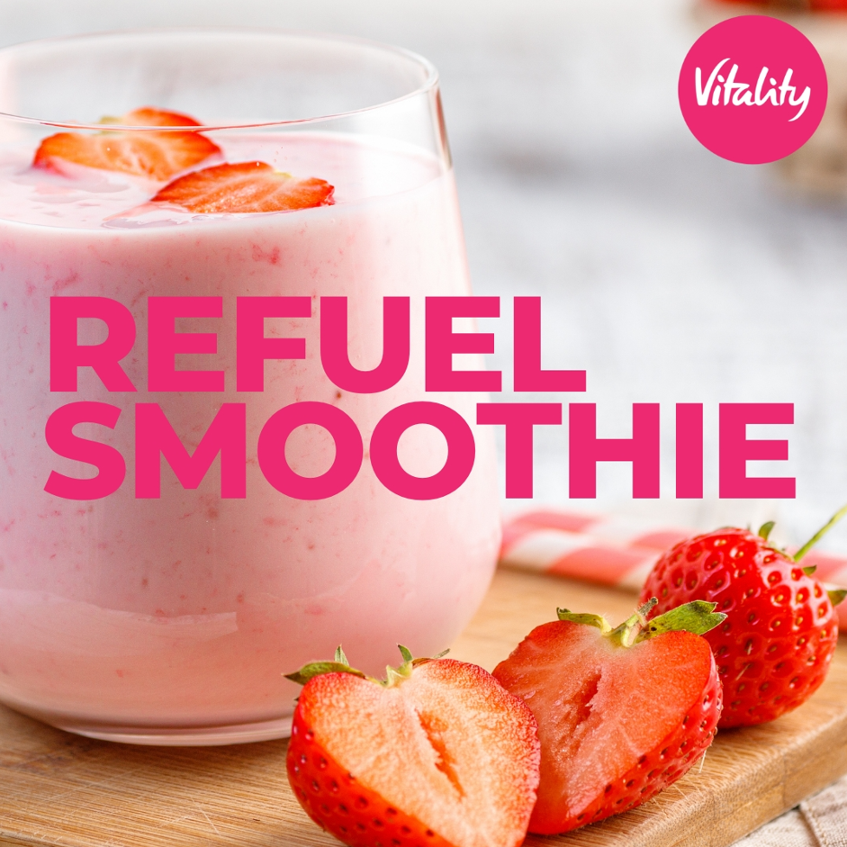

**INGREDIENTS**

* 1 apple, grated
* 200g strawberries (replace with mango, berries, or pineapple for variation)
* 1 banana
* 1 tbsp almond butter or peanut butter with no added salt or sugar
* 3 tbsp oat bran
* 1 cup low fat plain yoghurt
* ½ cup low fat milk
* 1 tsp honey

**METHOD**

1. Place yoghurt, milk, oats and nut butter in a food processor and blend until smooth for about 5 minutes.
2. Add the fruits and honey and continue blending for an additional 3 minutes.
3. Pour into chilled glasses and serve chilled.
4. To produce chilled smoothies easily, use frozen berries or freeze the banana the night before.

Serves: 3

Prep time: 10 min

Cook time: 0 min