**What to expect in a Vitality Health Check**

**(Spoiler: it’s quick *and* easy)**

What is a Vitality Health Check, how does it work and why is it important? Lee Corrigan, Senior Vice President of Product Development at Vitality Global answers all your questions about the simple set of preventive tests that can add healthy years to your life.

**Q: Why do I need a health check if I feel healthy?**

A: Doctors recommend getting simple, regular health checks throughout your lifetime to detect your risk of developing certain diseases as early as possible. The type of routine screening may differ depending on your age, gender, lifestyle, family and medical history.

For example, you should start checking your cholesterol and blood fasting sugar levels in your twenties to understand your risk of heart disease and diabetes. When you reach your forties, women should start screening for breast cancer while men should be checking for prostate cancer. However, if you have a family history of these cancers, doctors suggest that you start even earlier.

**Q: How can a Vitality Health Check help?**

A: A Vitality Health Check is a simple and convenient set of tests that you can do to identify your risk of developing a chronic condition. It includes four tests – blood pressure, cholesterol, glucose and a weight assessment.

So, by doing one simple Vitality Health Check, you can understand your risk of a wide range of lifestyle diseases and, together with your doctor, come up with a plan of action to lower your risk, change your lifestyle and improve your healthspan.

**Q: How do I get a Vitality Health Check?**

A: You can book a Vitality Health Check at a doctor or pharmacy in the Vitality Wellness Network. When you arrive for your appointment, the doctor or nurse will explain each measure in detail.

Once you complete the Vitality Health Check, the doctor or nurse will explain your results to you, answer your questions and give you advice on how to improve your results if they are out of range. Afterwards, Vitality will send you a detailed report to discuss with your doctor.

**Q: How many Vitality points can I earn?**

A: You can earn up to 22 500 Vitality points for completing a Vitality Health Check, based on how many of your results are in range and how many indicate an elevated risk of developing a disease related to your lifestyle:

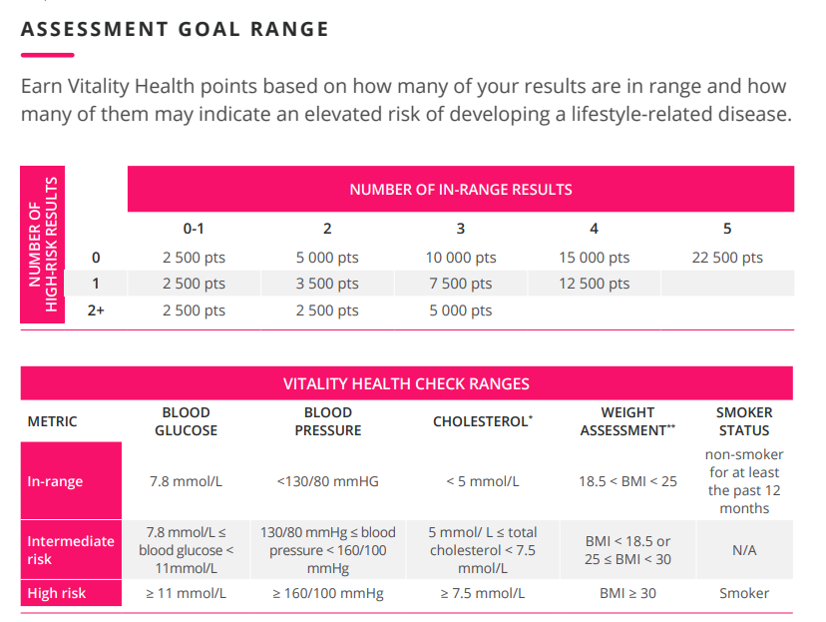

**Q: How much time do I need for a Vitality Health Check?**

A: You need 30 minutes at the most. A Vitality Health Check is a quick, easy and convenient way to test for major chronic conditions like cancer, heart disease and diabetes.

Plus, you can do a second Vitality Health Check 90 days after the first one, giving you plenty of time to make small behavior changes, improve your results and earn the maximum amount of Vitality points.

**Q: How much does it cost?**

A: As a Vitality member, you can get one Vitality Health Check a year, on us.

**Q: When is a good time to get a Vitality Health Check?**

A: I always get my whole family to go for a Vitality Health Check right at the start of every year. In behavioural science it’s called the fresh start effect. With the start of every milestone, like a new year, comes hope and optimism for a better life, making it the perfect time to start a new habit.

Another technique is to set a timely reminder to do your Vitality Health Check at the same time every year. Write it on your calendar or set a reminder on your cellphone to make it easy to remember. You’ll have the added benefit of keeping your maximum up to 25% back on HealthyFood when you do your Vitality Health Check every 12 months.