**Our dash of delicious with Vitality desserts**

We believe that healthy eating needs to be something you commit to for the long term – not just trendy diets or a beginning-of-the-year detox. That’s why we’re here to provide our Vitality members with healthy, tasty recipes that you can whip up in your own kitchen with fresh, seasonal ingredients plus minimal effort.

**Healthy eating doesn’t mean you don’t get to treat yourself**

… it just means opting for healthier options and maintaining that all-important balance in your diet.

We put this to the test with a challenge to Vitality dietitian, Terry Harris. We asked her to share healthy (and easy-to-make!) dessert recipes to inspire us all to get baking with our friends and family.

***CHOCOLATE TART WITH NUT CRUST***

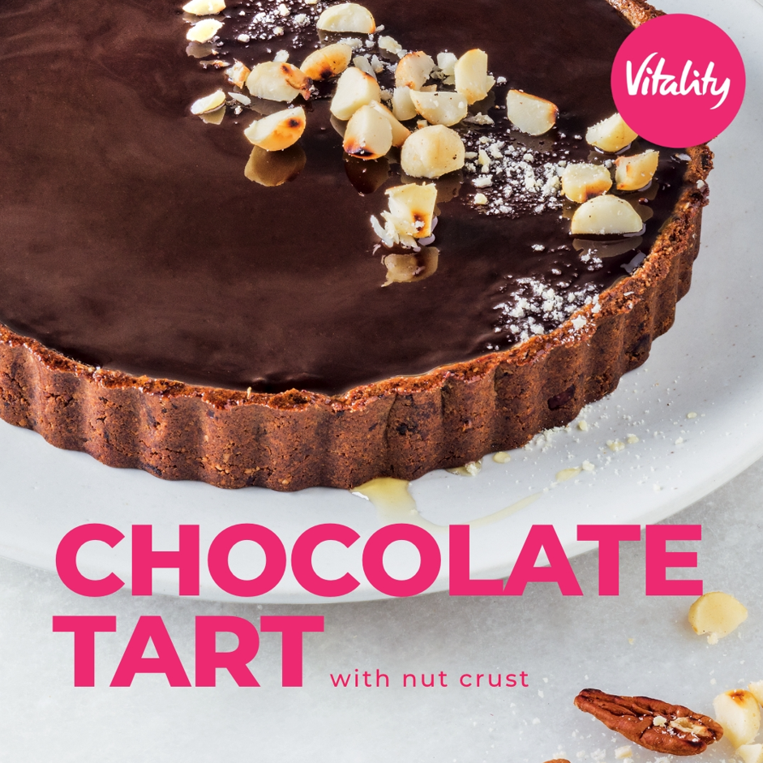

**INGREDIENTS**

150g almonds, ground

150g dates, dried  
450g 70% dark chocolate

550ml low fat milk

3 eggs  
90g unsalted macadamia nuts

90g unsalted pecan nuts  
30ml honey  
5ml water

**METHOD**

* Preheat oven to 160 ̊C or 320°F.
* Toast the ground almonds in the oven until golden. Remove from the oven and allow to cool.
* Blend almonds and dates in a food processer until the mixture binds together in a smooth paste.
* Line a 20cm tart tin with the ground almond mixture by pressing it into a thin layer covering the base and sides and place in the refrigerator until needed.
* Roast pecan nuts and macadamia nuts in the oven until they start to release aroma.
* Heat the milk on the stove until it comes to the boil. Pour over the chocolate and whisk until all the chocolate has melted. Allow to cool slightly before adding the eggs, which have been slightly whisked.
* Pour chocolate mixture into tart shell and decorate with the toasted nuts on top. Place tart in the oven and bake for 35 minutes or until set. Remove from the oven.
* Place honey and water in a teacup and melt in the microwave. Brush the top of the chocolate tart with the honey glaze.

***LEMON TART WITH COCONUT & DATE CRUST***

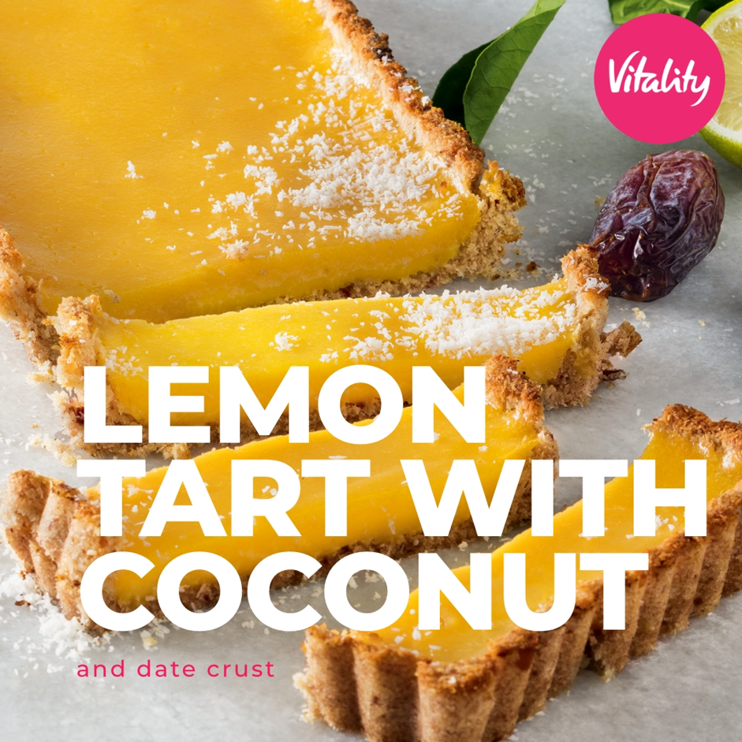

**INGREDIENTS**

140ml lemon juice  
80g unsalted butter  
80g granulated sugar  
2 eggs  
3 egg yolks  
180g desiccated coconut

150g dates  
40ml water

**METHOD**

* Preheat the oven to 170 ̊C or 338°F.
* Place the coconut, dates and water in a food processer and blend until smooth.
* Press coconut mixture into a greased 30cm tart case. Bake the tart case in the oven for 15 minutes or until dry.
* Place butter, sugar and lemon juice in a bowl over a double boiler. Whisk the mixture until the sugar has dissolved.
* Crack the eggs into a bowl, whisk them and slowly add to the lemon mixture. Continue to whisk until the lemon mixture thickens. The mixture needs to be able to coat the back of a spoon. Pour into the tart case and place in the refrigerator to set.
* Store any extra lemon curd in a sterilized jar. Lemon curd will last in the fridge for a few weeks.

Try out these recipes and post your kitchen selfies using the hashtag **#LiveLifeWithVitality** and we could be featuring YOU on our social media platforms.