Refuel smoothie recipe
Recipe developed by the Vitality HealthyFood Studio

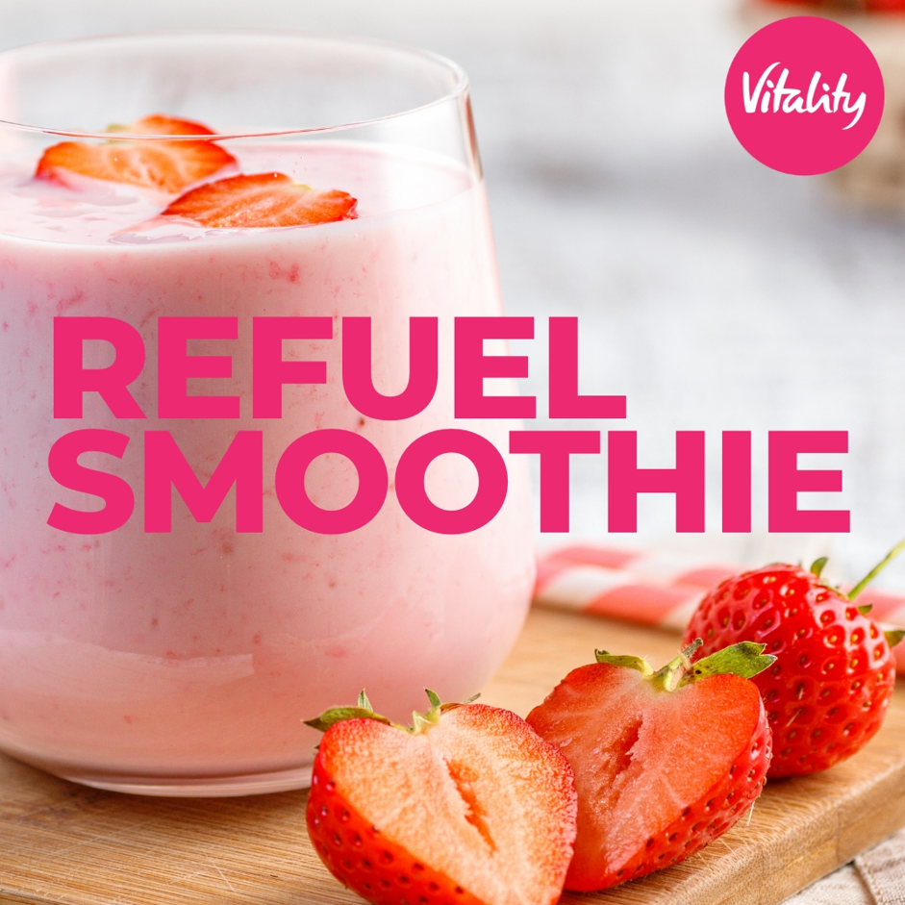

INGREDIENTS

- 1 apple, grated
- 200g strawberries (replace with mango, berries, or pineapple for variation)
- 1 banana
- 1 tbsp almond butter or peanut butter with no added salt or sugar
- 3 tbsp oat bran
- 1 cup low fat plain yoghurt
- ½ cup low fat milk
- 1 tsp honey

METHOD

- Place yoghurt, milk, oats and nut butter in a food processor and blend until smooth for about 5 minutes.
- Add the fruits and honey and continue blending for an additional 3 minutes.
- Pour into chilled glasses and serve chilled.
- To produce chilled smoothies easily, use frozen berries or freeze the banana the night before.

Serves: 3
Prep time: 10 min
Cook time: 0 min

