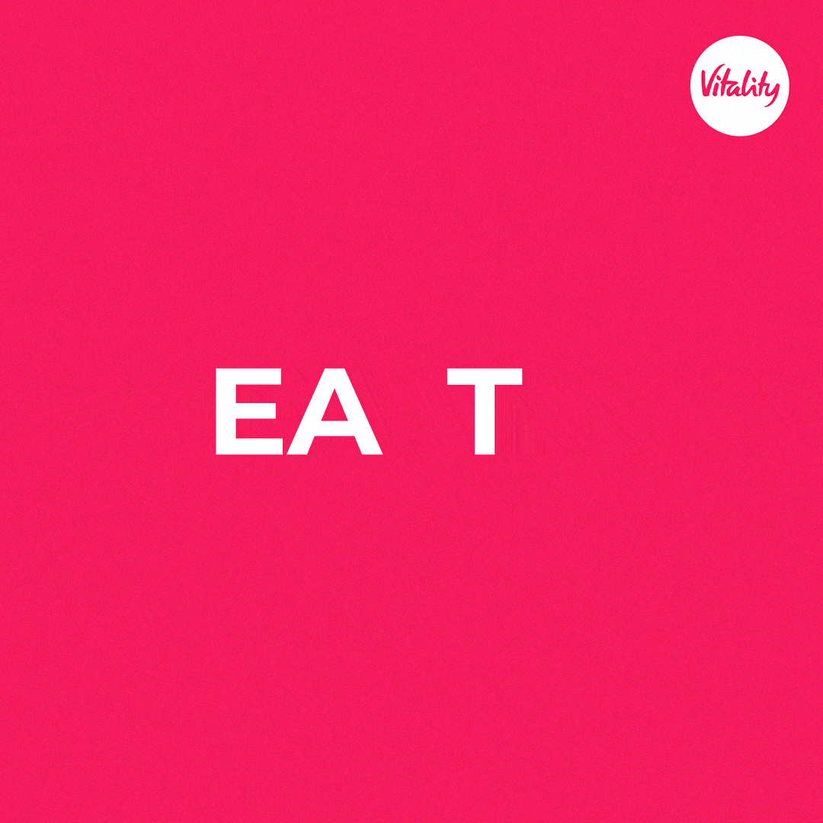

Barriers to healthy eating – and how Vitality can help

We all know how important it is to eat healthy food.
But, for many reasons, sometimes it’s a battle to get this right.

A big part of healthy eating comes down to habits. This is what we do daily – or on a regular basis – and takes time and patience. Building healthier habits starts with setting your health goals, identifying challenges you may face, making the new habit easy and fun and getting the right support to make sure you stick to it.

An important step here is to figure out what your barriers are to success.

James Vickers, nutrition expert at Vitality UK, suggests asking yourself some questions:

Have you tried to change your eating habits before?
If yes, what did you find difficult or unsustainable?
What simple, small change can you make first?

Once you’ve identified what’s preventing you from eating more healthily, you’re better able to come up with a plan to get past this, changing bad eating habits into good/better/best ones.

We’ve put together some common behavioural barriers to healthy eating below – and added Vitality tips and tools to help you overcome these on your journey to better health.

But first, let’s start with some background info.

Unhealthy diets are linked to several noncommunicable diseases (NDCs), also known as chronic diseases of lifestyle, including obesity, heart disease Type 2 diabetes, high cholesterol, hypertension and even some cancers.

These diseases are driven by common dietary risk factors like too much salt, sugar, trans fats and too little fruit and veg, fibre and grains in what you eat.

The worrying part?
NCDs contribute to 71% of all deaths globally.

The silver lining?
NDCs can (largely) be prevented or at least managed through healthier eating.

If you’re trying to eat more healthily, the following 3 barriers may be challenges you need to overcome:

Barrier 1:
“I don’t find healthy food tasty and there is a lack of variety”

This is a common misconception and couldn’t be further from the truth. In fact, a cornerstone to heathier eating is to enjoy a variety of foods which means exploring all food groups –grains, protein, vegetables and fruit, fats and dairy. This variety alone means different tastes and textures while still giving your body the essential nutrients it needs to function. Also, you can start slow. You don’t have to give up all the foods you love eating. Start by making small changes so you have time to adjust. As an example, if you like pizza, start by adding some extra vegetables as toppings.

Barrier 2:
“I don’t have time to cook or prepare healthy meals”

At Vitality, we believe that preparing quick and healthy meals should be easy. A few time-saving tips here include chopping or slicing the full veg (like an onion or carrot) and then storing the leftovers so that you don’t need to prep much the next time. This makes it easier to grab-and-go and still get the healthy meal in. Even better: cook meals when you have the time and stash them in the freezer. Healthy soups and stews are great options here. Also, stock up on healthy pantry essentials, such as wholegrains (e.g. brown rice) and tinned legumes (e.g. beans and peas). This means you have what you need to throw together quick, healthy meals without needing to get to a grocery store or defaulting to unhealthy options.

Barrier 3:
“Healthy food is more expensive”

If you’ve ever said these words, we’ve got some solutions. Make a grocery list of what you need before you go to the grocery store and try to stick to it. Also, avoid going shopping when you’re hungry as you’re more likely to go off-script and impulse buy which ends up costing unnecessary money. Choose fruit and vegetables that are local and in season. These are not only cheaper, but usually more flavourful too. You can even save on electricity or energy costs by making more meals that do not require cooking, such as salads.

Let Vitality help
The Vitality programme offers a range of recipes for healthy, affordable meals – and if you have the Vitality HealthyFood benefit, you’ll even save money by getting cash back when you shop healthier at our partner grocery stores.

Here are some of our favourite recipes – no matter the season – to try out at home.
- Lentil and butternut salad – using longer lasting healthy food
- Mediterranean chicken & quinoa casserole – freeze it for later
- Mexican 3-bean salad – for a healthy, filling lunch
- Quick seed loaf – so easy the family can help, too
- Healthy snacks on the go – creamy tuna spread and seed and almond nut crackers are great to save you time
Happy (healthy) eating!

