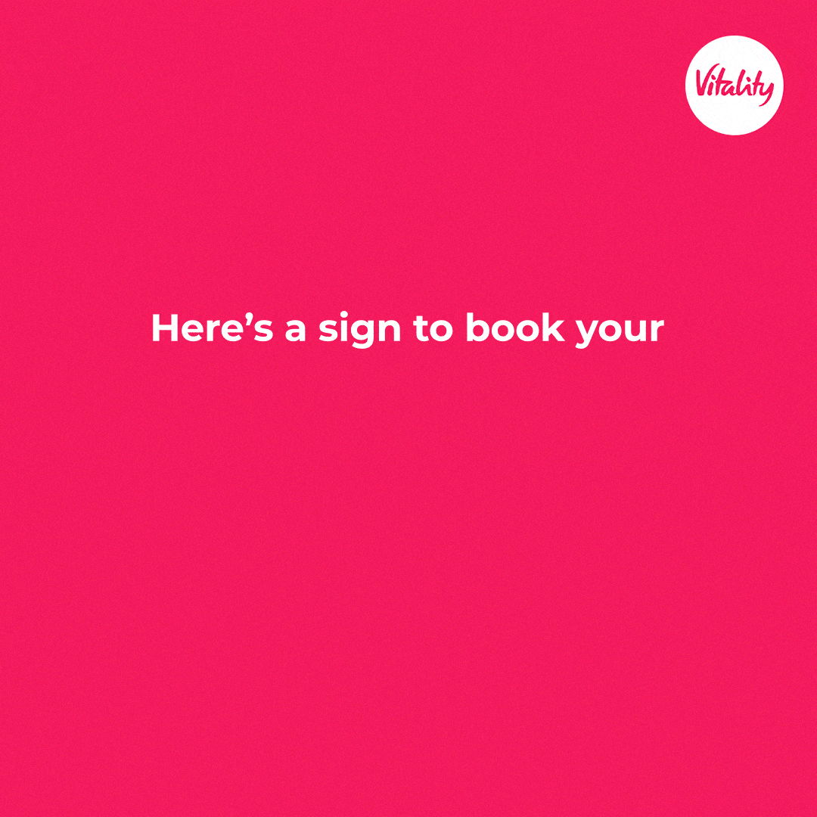

4 screenings. 15 minutes. A lifetime of better health.

Every hour, 1 000 health assessments are done by Vitality members around the world. We’re proud of this impressive number – now let’s add your annual health check to this tally, too.

The Vitality Health Check – or VHC – is a simple set of health screenings to identify your risk of developing a chronic condition and also gain an understanding of your current state of health – to help you start taking the right steps to improve your health. Health risks across different measures are identified, including blood pressure, cholesterol, glucose, weight, and smoking status.

As a Vitality member, you’re probably already familiar with this annual check. Its main purpose is to help you answer these important questions:

How well do I know my body?
How healthy am I?
What is my risk of developing illness?

Another question is:
Can a Vitality Health Check save my life?

Yes, it did for Discovery Vitality member, Amy Rabie when she found out that the cause of her ongoing tiredness, headaches, constant thirst and blurry vision was undiagnosed (and life-threatening) Type 1 diabetes!

By doing these screenings once a year, you can better understand how your body works and what you need to do to take care of it. A big advantage of these regular checks is that you’ll be empowered with the knowledge to take control of your health and enjoy a healthier future.

Prevention > treatment

According to Dr Jonathan Dugas, who holds a PhD in Exercise Physiology and is a long-time health consultant for Vitality USA, “getting regular and medically recommended screenings is one of the most important things you can do for your health. The early detection of disease can save lives”.

Dugas adds that by doing a quick VHC each year, you can better understand your risk of a wide range of lifestyle diseases and, together with your doctor, come up with a plan of action to lower your risk, change your lifestyle and improve your healthspan (the number of years you can expect to live in good health, free from the chronic diseases that come with ageing).

“With a global presence in 40 markets, Vitality data continues to show the benefits of routine screenings. People who get regular health checks are better able to detect a disease or health condition early, and this can improve long-term outcomes – more effective treatment options, less severe illness and the possibility to greatly improve longevity,” says Dugas.

Healthy habits = healthier health checks

Some positive news is that keeping your health in check comes down to healthy habits and lifestyle changes. The three main things you need to focus on? Eating healthy, exercising regularly and taking any prescribed medication correctly.

Quick Q&A to answer your VHC questions

Why do I need a health check if I feel healthy?
Doctors recommend getting simple, regular health checks throughout your lifetime to detect your risk of developing certain diseases as early as possible. The type of routine screening may differ depending on your age, gender, lifestyle, family and medical history. Even if you’re feeling healthy, some symptoms may be hidden and only diagnosed by these tests.

How do I prepare for my VHC?
Don’t eat or drink 8 hours before your appointment so that your health metrics aren’t affected by any changes in blood sugar levels or digestive processes. Bring an ID and proof of your Vitality membership.

What happens once I’ve completed a Vitality Health Check?
By completing a Vitality Health Check you’ll earn Vitality points based on how many of your results are in-range versus how many show risks of you developing an NCD. The healthier you are, the more points you earn, accumulating towards your Vitality status and greater rewards.

Next steps

Now that you’ve finished reading this, we have an easy next step: take out your diary or go into the calendar section of your phone or laptop and pick a day and time to schedule your VHC.

Visit one of our partner healthcare professionals to complete your Vitality Health Check and enjoy your Vitality points.

Book your VHC today.

